00000000000000000000000000000000000000000000`1

Upcoming events for October

September 29

Pizza sale @ upper campus

October 5

SPC Elections Thursday

Library 6PM

October 6

Junior Achievement Day

Grade 4 Field Trip

October 9

No School Columbus day

October 10

Progress Reports

Gr. 6-8

October 11

Drama Booster Meeting

Library 6PM

October 12

Last Day for Clothing Drive

October 13

MS Cyber presentation 2Pm

Grade 5 Field Trip

October 17

Picture Day Lower and Upper

October 20

Pizza Sale Upper Campus

Friday 10/27

Walk-a -thon

October 31

Halloween

K2 Field Trip TBD

**Roosevelt School Big Time News**

**September 28, 2017**  

Big Time News – November 1, 2016

**Principal's Corner**

**Welcome Back!**

Happy October! We have had a strong start to the school year and everyone is settling into their new routines. Our instructional focus will continue this year at the Roosevelt: engaging students in evidence based academic conversations and writing. With our youngest students this means learning the behaviors of a conversation while at the higher grades our students will learn the skills of making a claim, supporting it with evidence and reasoning and debating that claim.  Please ask your children about academic conversations they are having in school.

.

**From the desk of Caroline Myers** We are approaching that time of year when colds, flu and other viruses are at their peak.  Headache, sore throat, cough, vomiting, diarrhea, and aches are some of the symptoms.

A child who has any of these symptoms and has a**FEVER** should **not**come to school. Your child can’t learn well when he/she is ill and other students and the staff are at risk for also becoming ill.

So please keep your child home until your child is feeling better and **is fever free for 24 hours without fever medicine.**  Call the school so they know the reason your child is absent. If your child is not improving, please call your child’s medical provider.

Don’t forget to send in a note!!

School Nurse Caroline Myers RN



We are approaching that time of year when colds, flu and other viruses are at their peak.  Headache, sore throat, cough, vomiting, diarrhea, and aches are some of the symptoms.

A child who has any of these symptoms and has a**FEVER** should **not**come to school. Your child can’t learn well when he/she is ill and other students and the staff are at risk for also becoming ill.

So please keep your child home until your child is feeling better and **is fever free for 24 hours without fever medicine.**  Call the school so they know the reason your child is absent. If your child is not improving, please call your child’s medical provider.

School Nurse

Caroline Myers RN



We are approaching that time of year when colds, flu and other viruses are at their peak.  Headache, sore throat, cough, vomiting, diarrhea, and aches are some of the symptoms.

A child who has any of these symptoms and has a**FEVER** should **not**come to school. Your child can’t learn well when he/she is ill and other students and the staff are at risk for also becoming ill.

So please keep your child home until your child is feeling better and **is fever free for 24 hours without fever medicine.**  Call the school so they know the reason your child is absent. If your child is not improving, please call your child’s medical provider.

School Nurse

Caroline Myers RN

**Core value for October Cooperation: An act or instance of working or acting together for a common purpose or benefit; joint action.**

**K1 News!**

K1 is off to a great start. We are adjusting to the classroom routines, learning how to transition throughout the day and making new friends. In the first few weeks of school we read many of the Bucket Filler Books. Each book discusses how we each have an invisible bucket that holds our good thoughts and feelings. The children fill each other’s “buckets” with “drops” of good deeds throughout the day…and they fill ours too! Next week will be moving into our Family Unit and we look forward to getting to know your family!

We appreciate the home-school relationship and look forward to being part of your child's learning journey! We will have a fun year filled with hands on learning and lots of exploration!

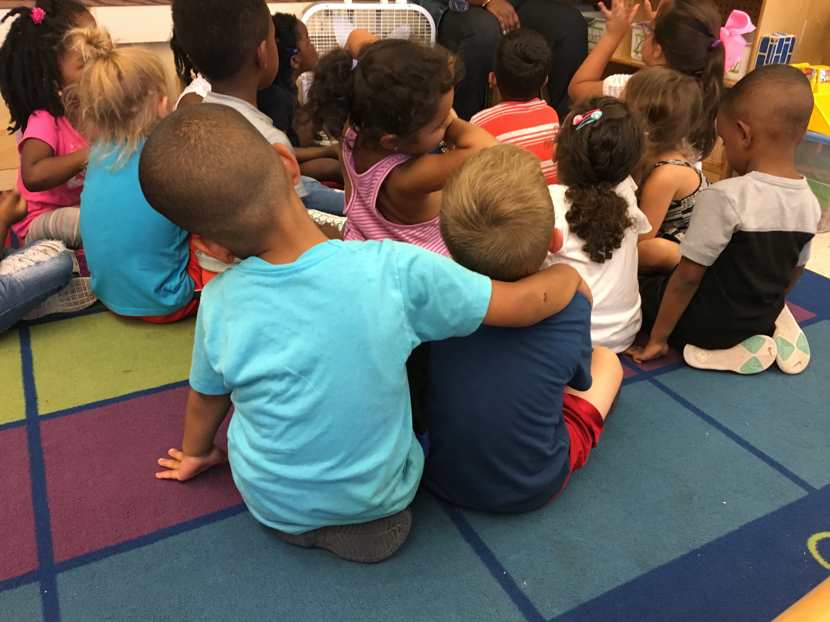

|  |
| --- |
| **Save the Dates!**  Our first main stage production of the season will be  **"The Prince and the Pauper"**.  We will perform at Riverside Theater Works November 16-18.  Tickets will go on sale on October 16th at [www.fdrdramaclub.brownpapertickets.com](http://www.fdrdramaclub.brownpapertickets.com/).  If you prefer, you can fill out a paper order form in the main office starting on October 16th and we will reserve your seats.  **Patriots Tickets**  *Do you know any Patriots fans?*  Don't miss this opportunity to win  **2 tickets** to see the Patriots at  Gillette Stadium!  We are raffling 2 tickets to the Patriots game against the  Miami Dolphins on  Sunday, November 26th  at 1pm.  Tickets are $5 each or 3 tickets for $10.  You can purchase tickets in the main office or you can send in your ticket request with cash in a sealed envelope and we'll send the tickets home.  Proceeds benefit the FDR Drama Club.  **Pizza Sale**  The Drama Boosters Club will be selling pizza during all 3 lunches at upper campus on the following dates:  September 29th & October 20th. Students will be able to purchase pizza ($2/slice), water bottles ($1 each), and juice boxes ($1 each).  All proceeds benefit the FDR Drama Club. |

# 

**Principal Lynda-Lee Sheridan**

**Assistant Principal Bannet Steele**

**Upper Campus**: 95 Needham Road, Hyde Park, MA 02136

P: 617-635-8676

F: 617-635-8679

**Lower Campus**: 30 Millstone Road, Hyde Park, MA 02136

P: 617-635-9280

F: 617-635-9284

Please visit our website at **bostonpublicschools.org/Roosevelt**

To find all general information about the school and classroom web pages. You can also stay informed through **Twitter @RooseveltK8BPS**



**SAVE THE DATE: 1St Annual Roosevelt Swap!**

It’s that time of year to clean out your kids’ closets, basement, and garage.  Drop off your items between now and October 12 at Upper Campus (driveway behind school) or Lower Campus (next to shed behind school)**.**

On **Thursday, October 12th from 3:15 pm to 5:30 pm,**come “shop” in the Upper Campus Cafeteria (95 Needham Rd, HP). 

All items that have not been swapped will be provided to Savers for funds that will be allocated to the FDR Drama Club.

**Most Needed Items:**

* Children’s clothing and coats
* Children’s shoes and boots
* Children’s socks, underwear and pajamas (accepted in new condition)
* Children’s books
* Brand new school supplies

To make this event possible, we need volunteers to help set up, sort donations, and clean up.  Any time you can volunteer between 1:30 pm and 6:30 pm on Thursday, October 12 will be greatly appreciated!  Please contact Neely O’Donnell (on Facebook or [neelyod@hotmail.com](mailto:neelyod@hotmail.com)) to sign up today!

**Save the Date**



**Grade 3 Update**

Grade 3 is off to a great start!  Students have been learning the class rules and routines and they are busy keeping themselves organized with the help of their binders, notebooks, folders, agenda books and supply caddy’s.  This year we welcome Ms. Santiago as our new third grade teacher.  She comes to us from the Tobin School, where she taught computers to students in grades K-8.  Ms. Santiago loves teaching and she is happy to be at the Roosevelt School!

There is a lot to learn in grade three and we have begun with some interesting topics.

In Social Studies students are learning about the Wampanoag’s and the Pilgrims in preparation for our November field trip to Plimoth Plantation.  Our Math curriculum begins with a multiplication unit and we are learning about things that come in equal groups.  In ELA students are using the classroom libraries to choose books for independent reading as they move from learning-to-read to reading-to-learn.   We are looking forward to a great year in grade three!

**SPC Corner** 

|  |  |
| --- | --- |
|  | Next SPC meeting will be held October 5 at 6pm at the Upper campus.  This will also be our annual Elections for SPC Executive Board and School Site Council members. The following are open positions!! Please consider becoming involved...  SPC Executive Board  Co-Chairs (2 positions)  Secretary (2 positions)  Treasurer (2 positions)  City Wide Parent Council  SPED PAC Rep  DELLAC Rep  School Site Council open positions:  2 School Site Council Rep positions are open and 1 position open for an Alternate  If you want or need additional information about these positions, please feel free to email Pam Bellamy [blish3939@hotmail.com](mailto:blish3939@hotmail.com" \t "_blank) |

